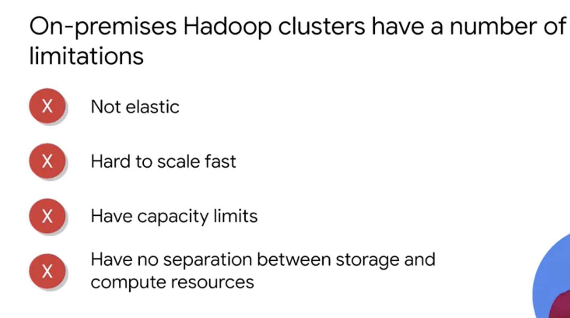

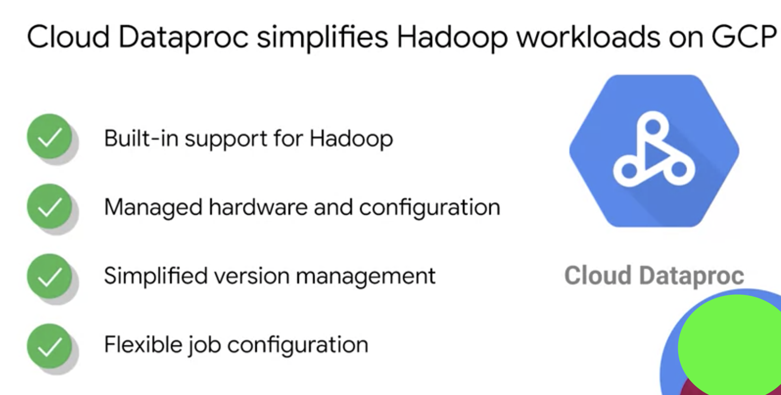

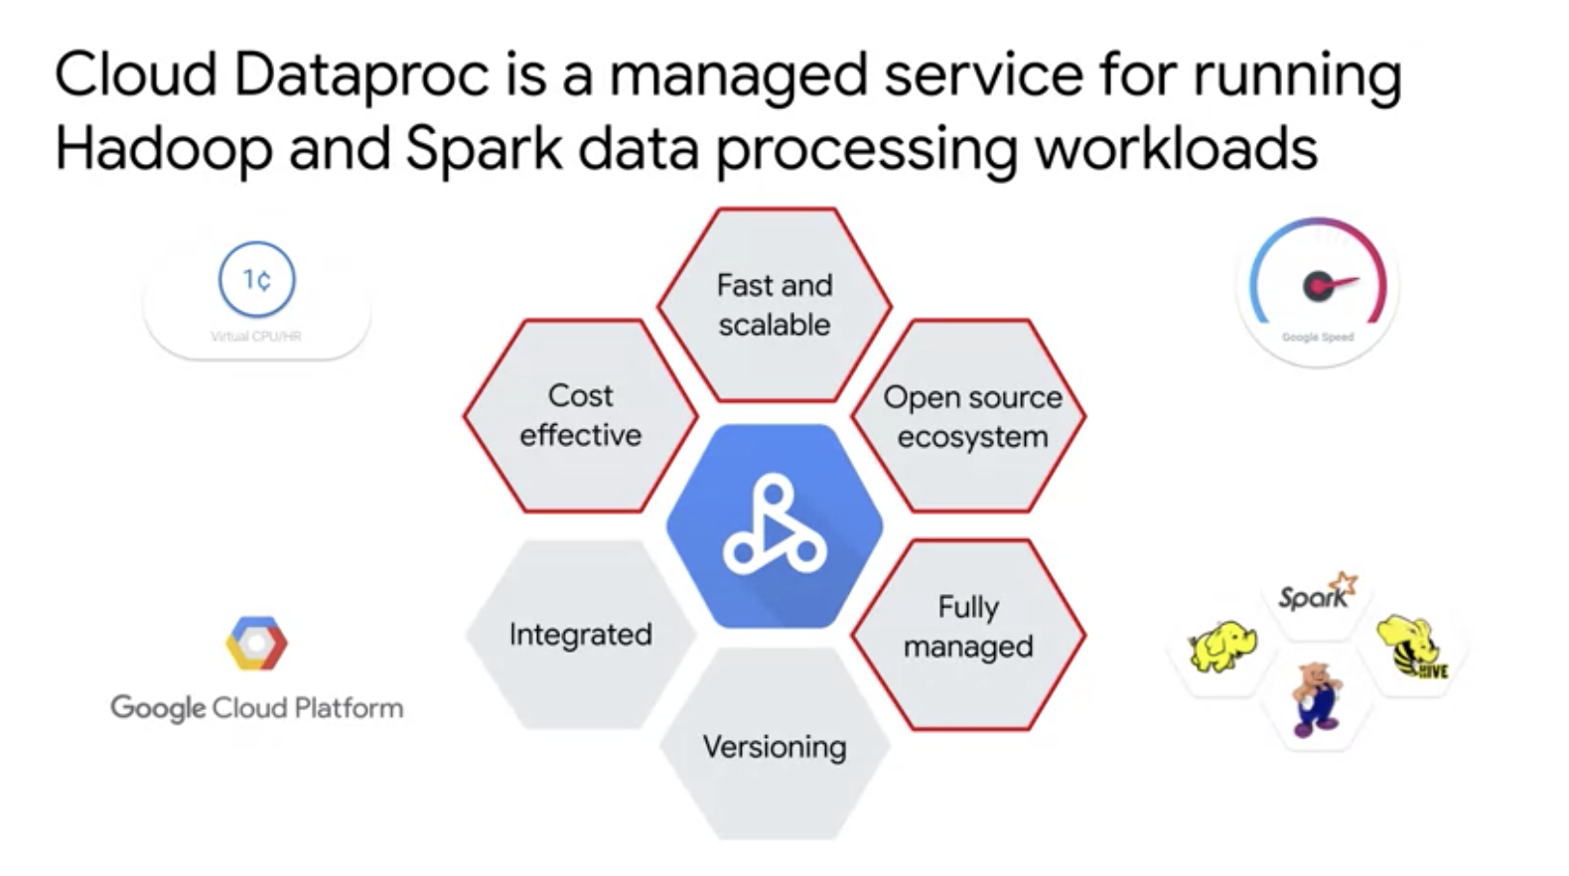

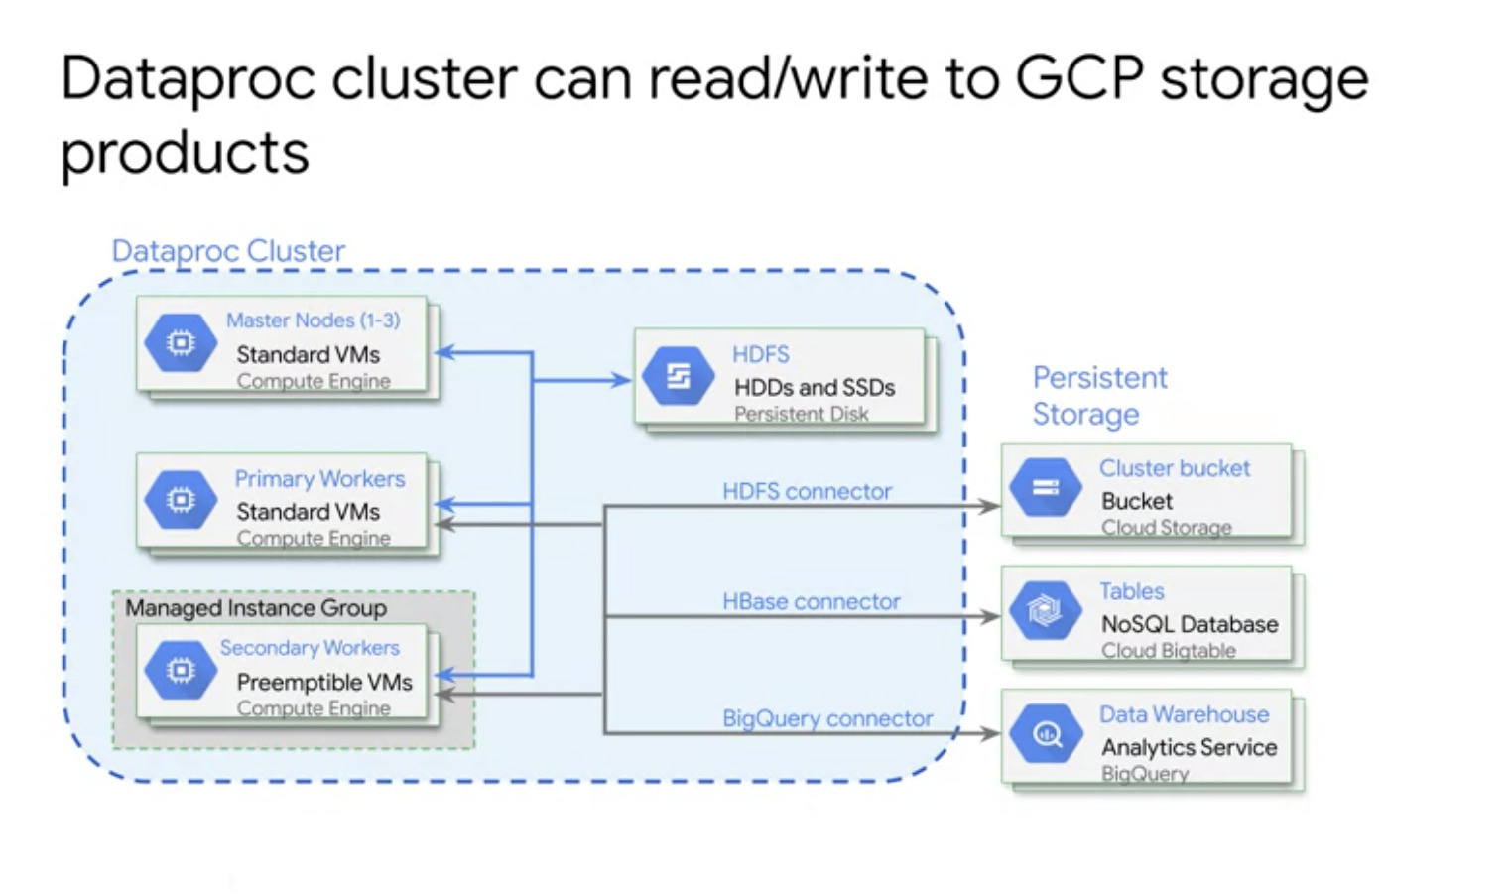

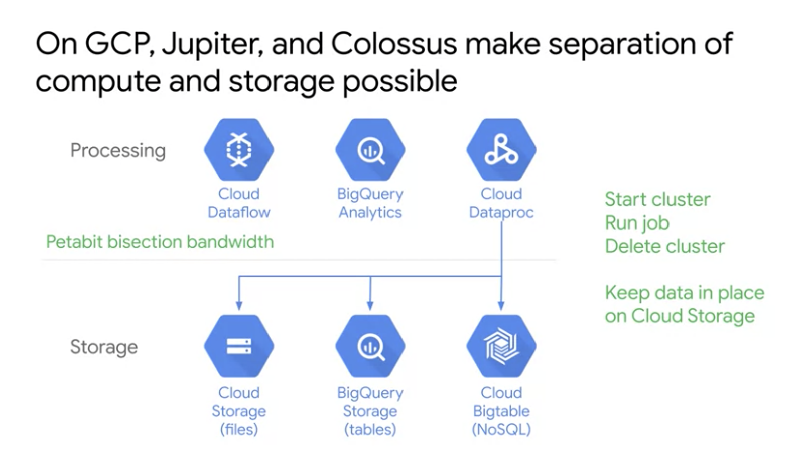

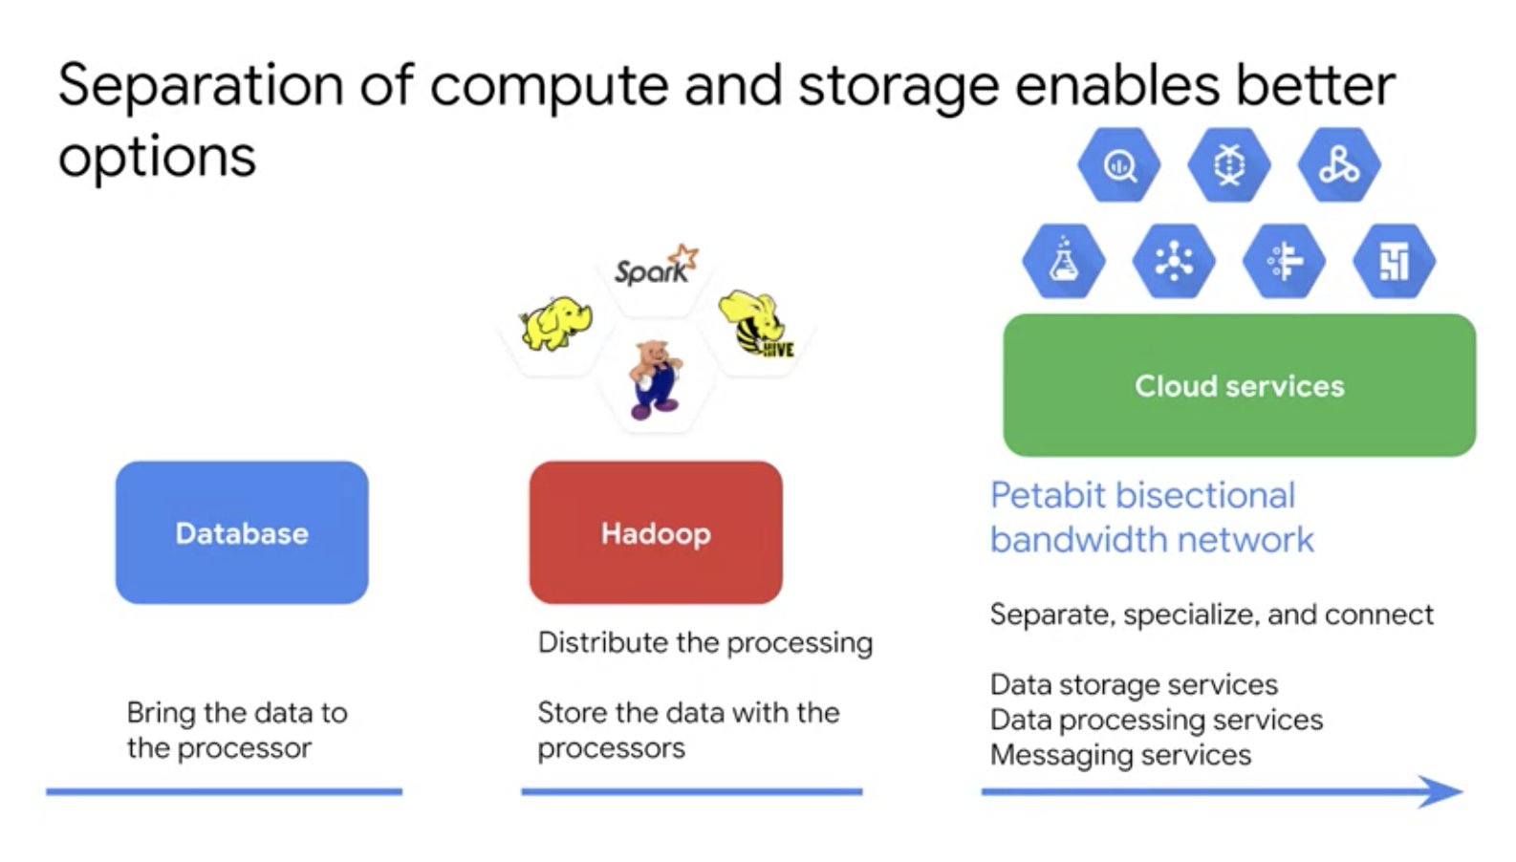

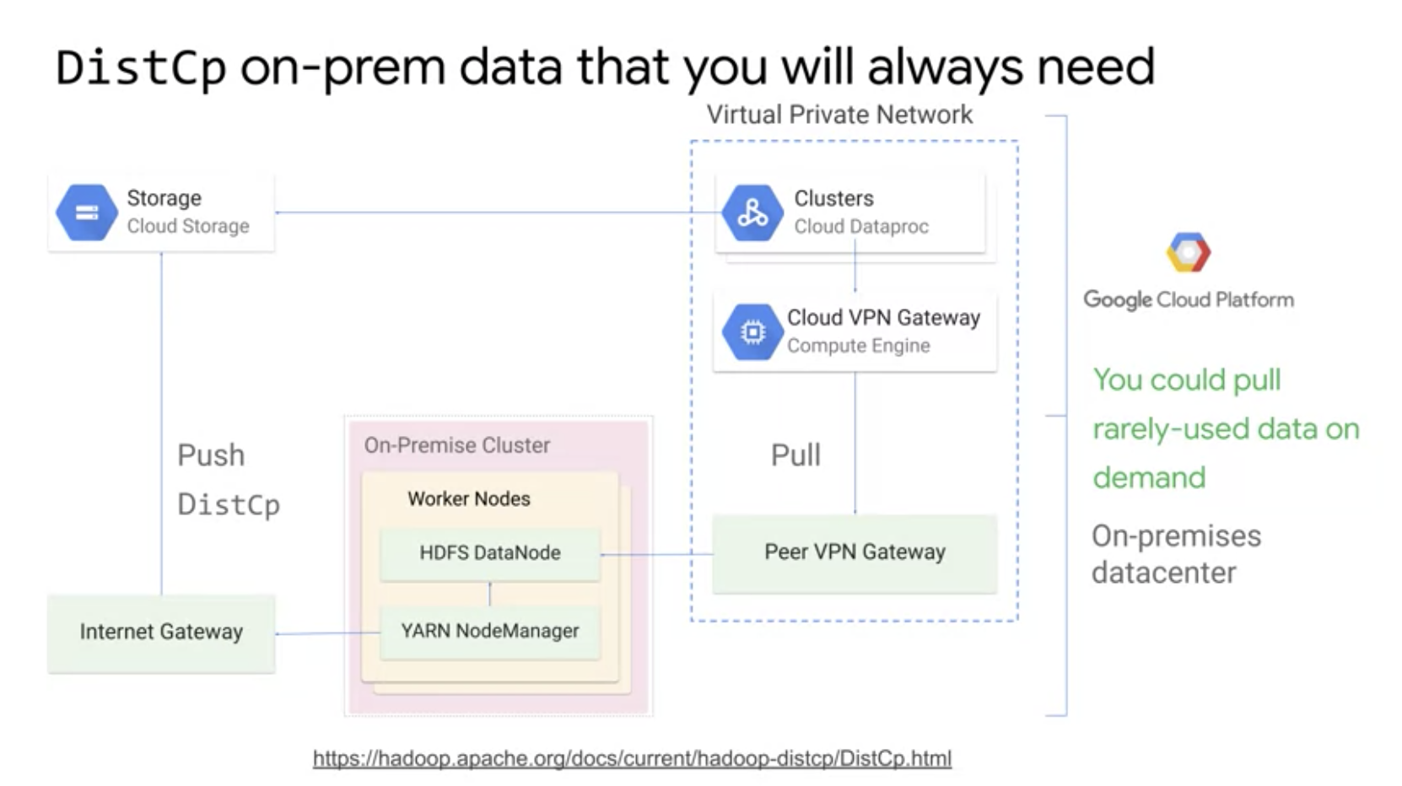

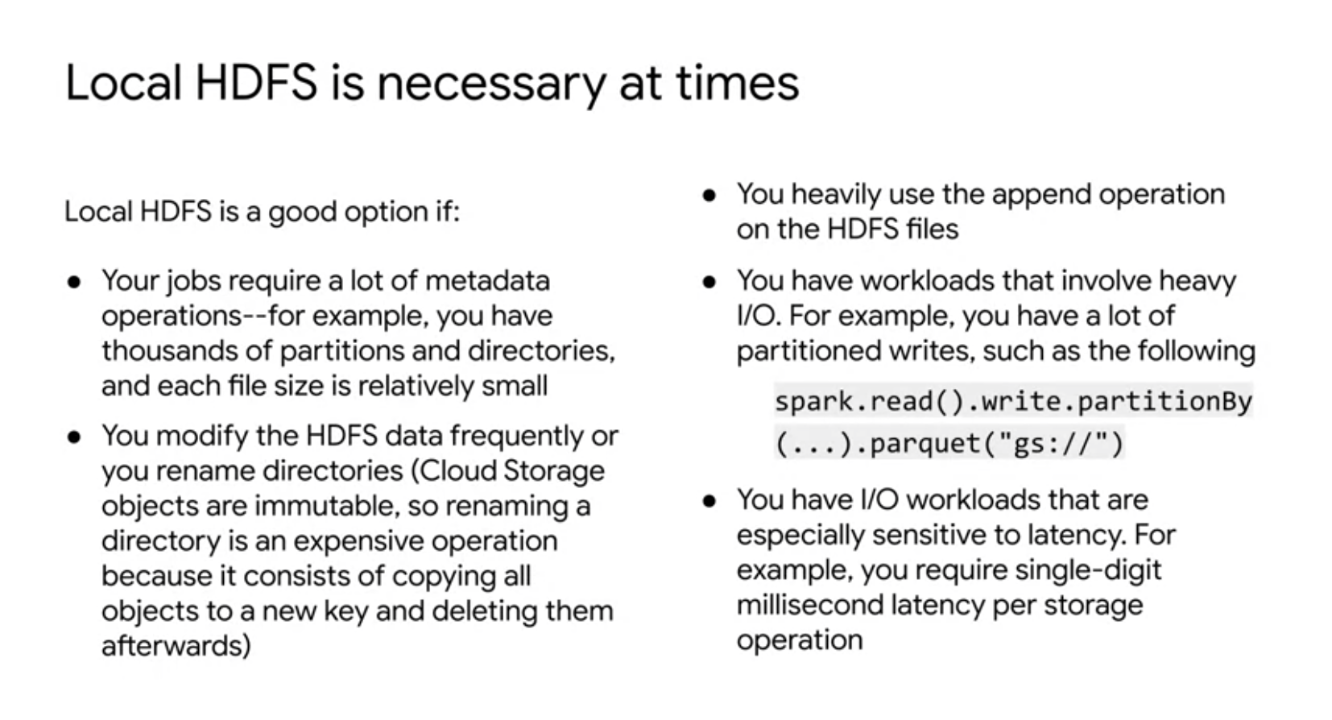

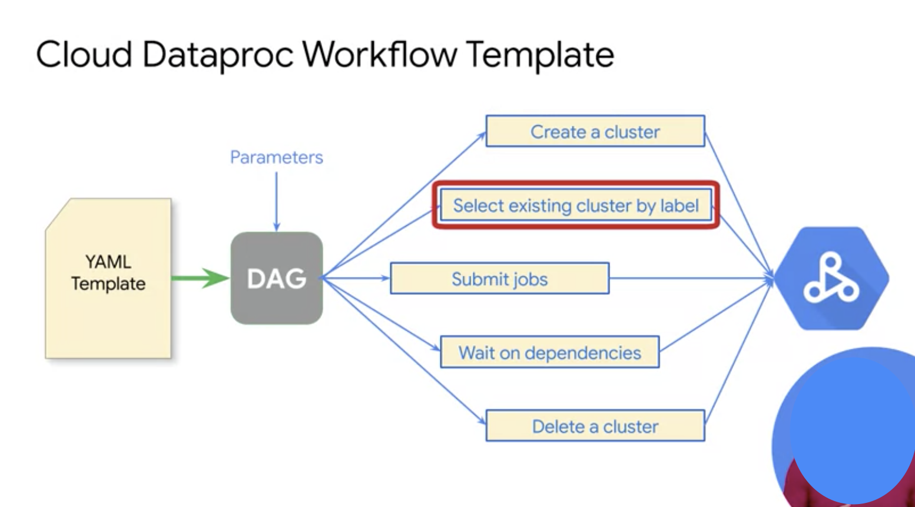

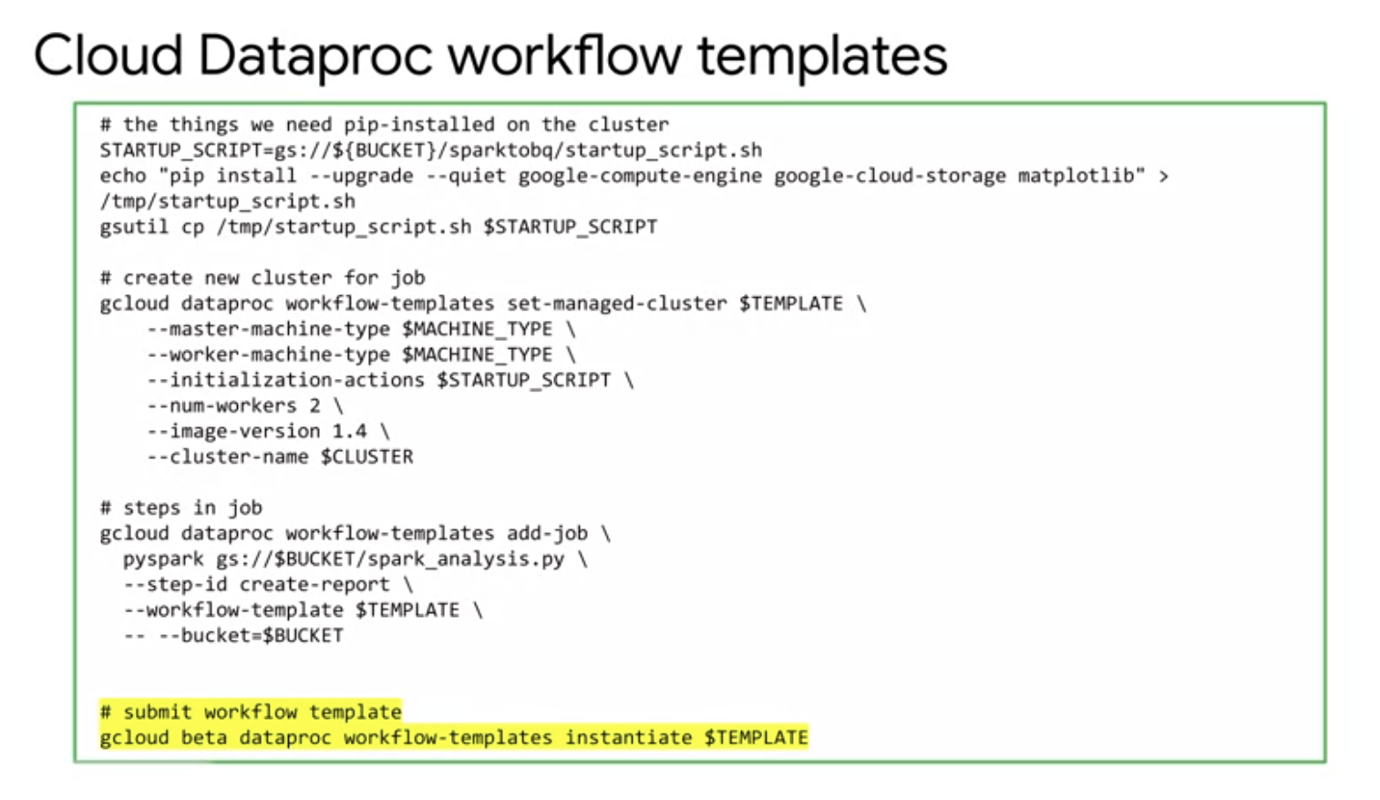

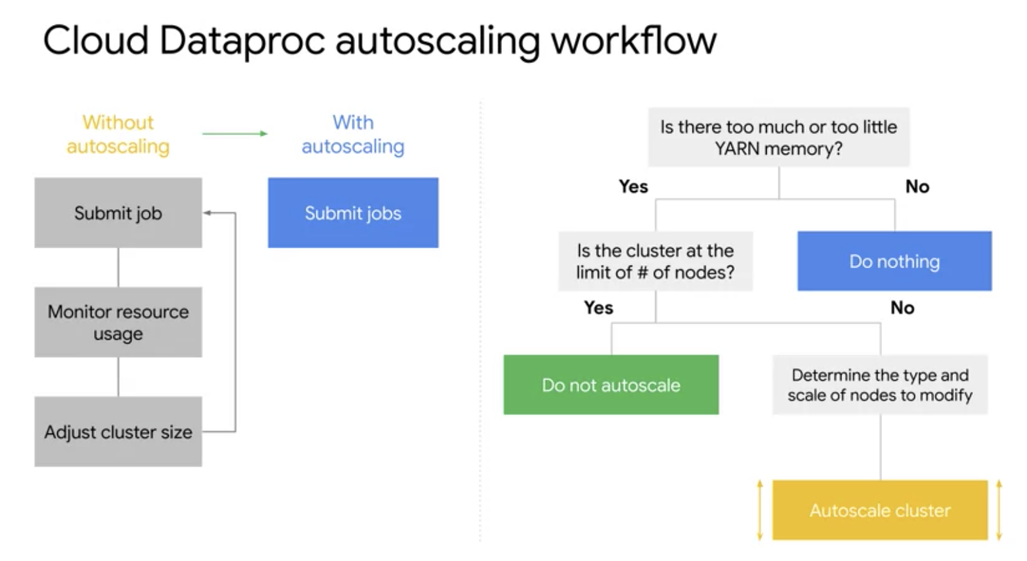

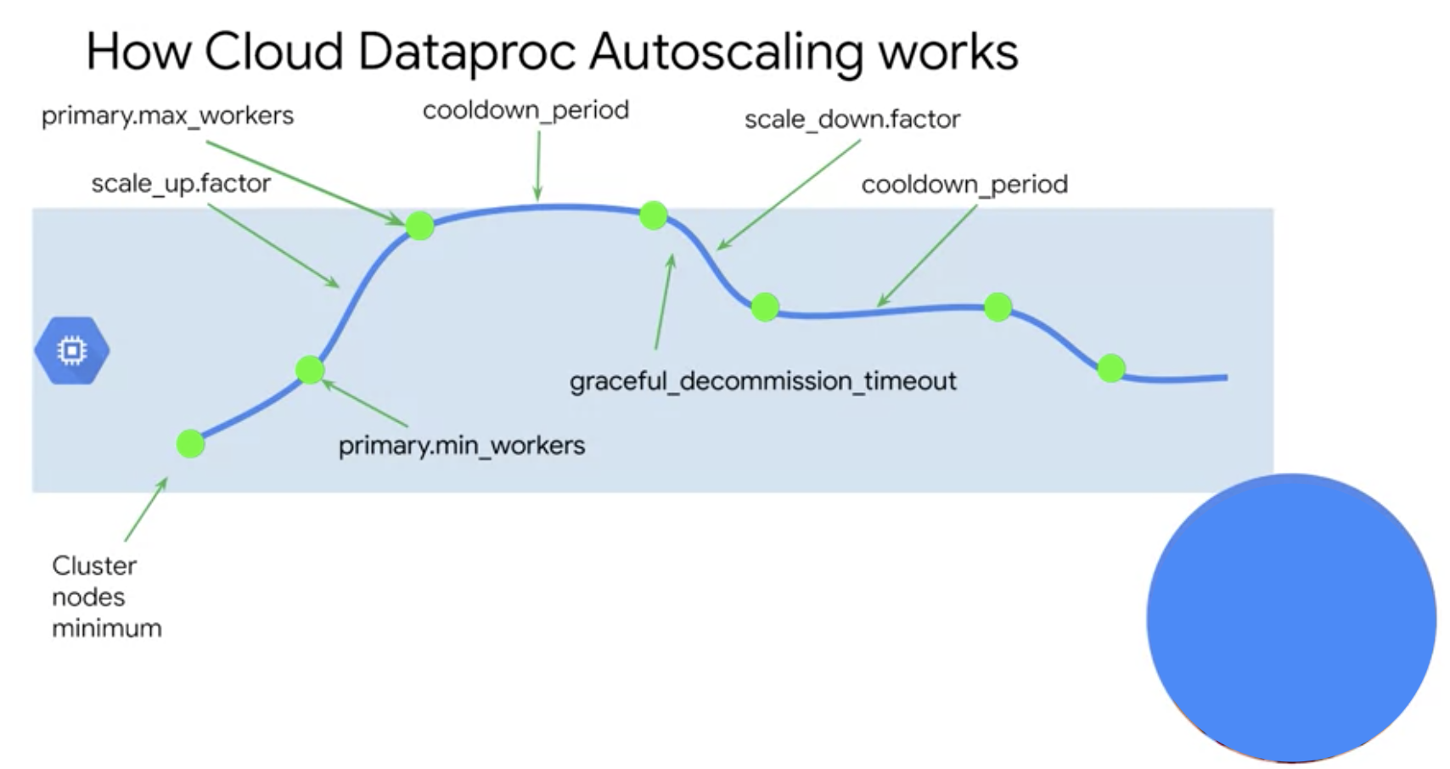

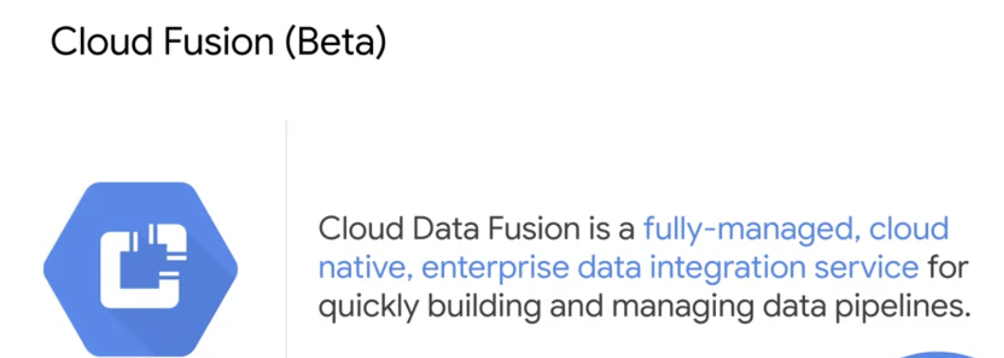

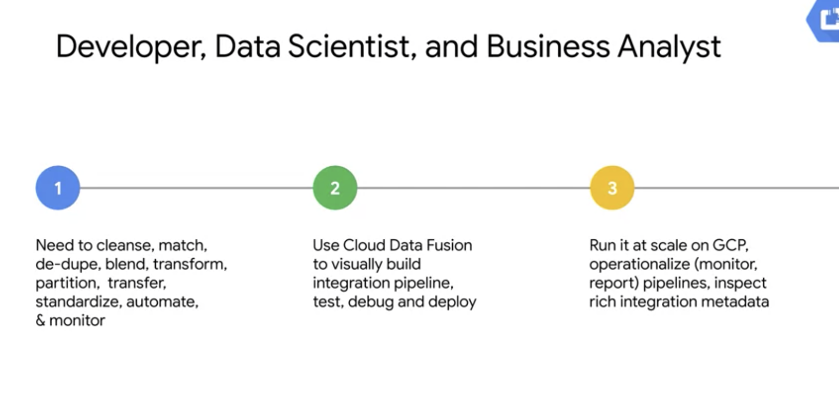

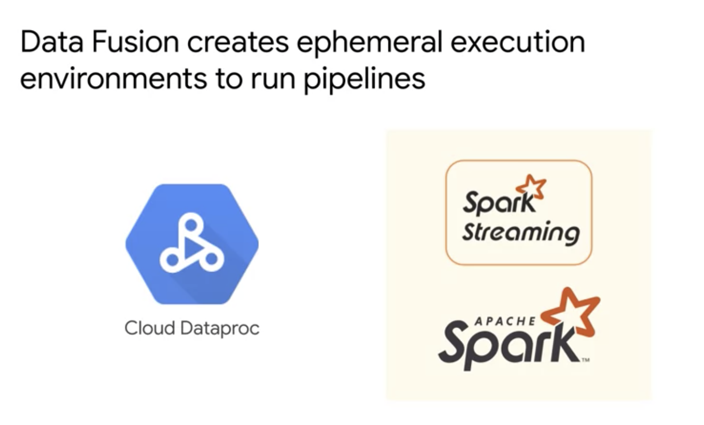

Cloud Data Fusion translates your visually built pipeline into an Apache Spark or MapReduce program that executes transformations on an ephemeral Cloud Dataproc cluster in parallel. This enables you to easily execute complex transformations over vast quantities of data in a scalable, reliable manner, without having to wrestle with infrastructure and technology.

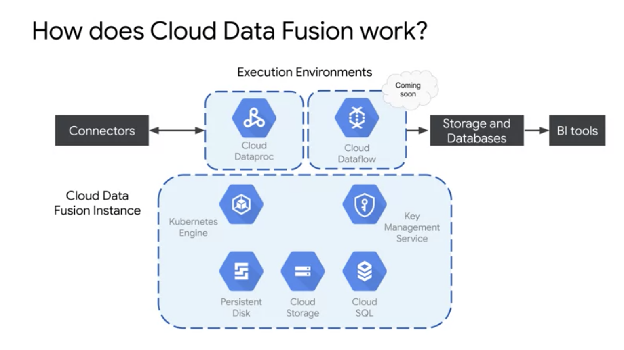

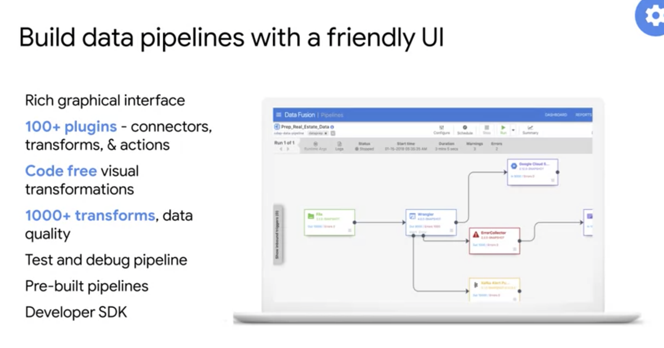

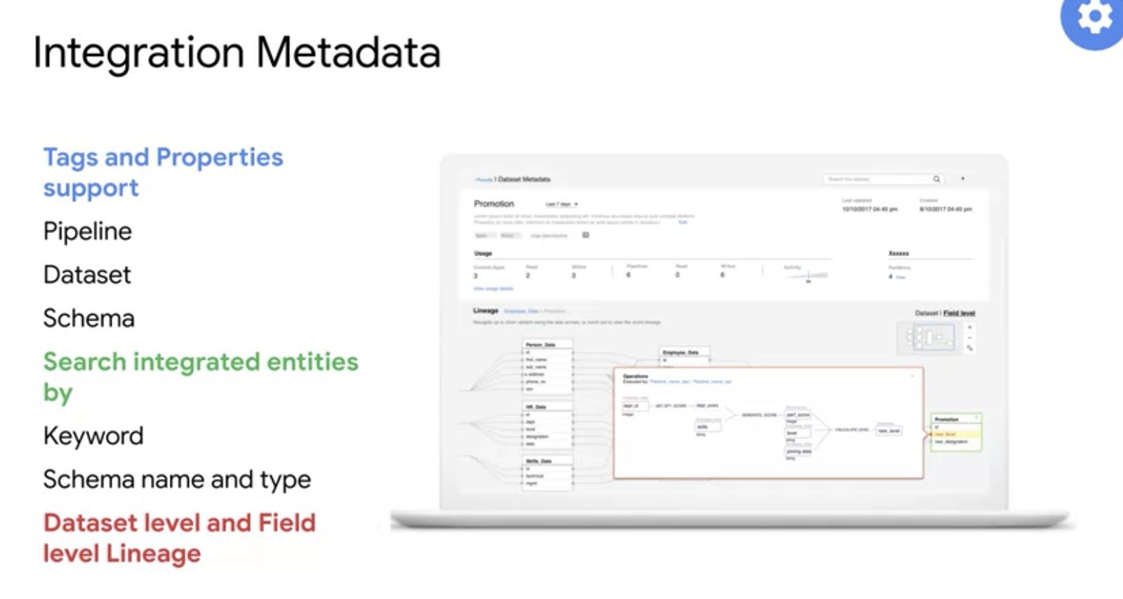

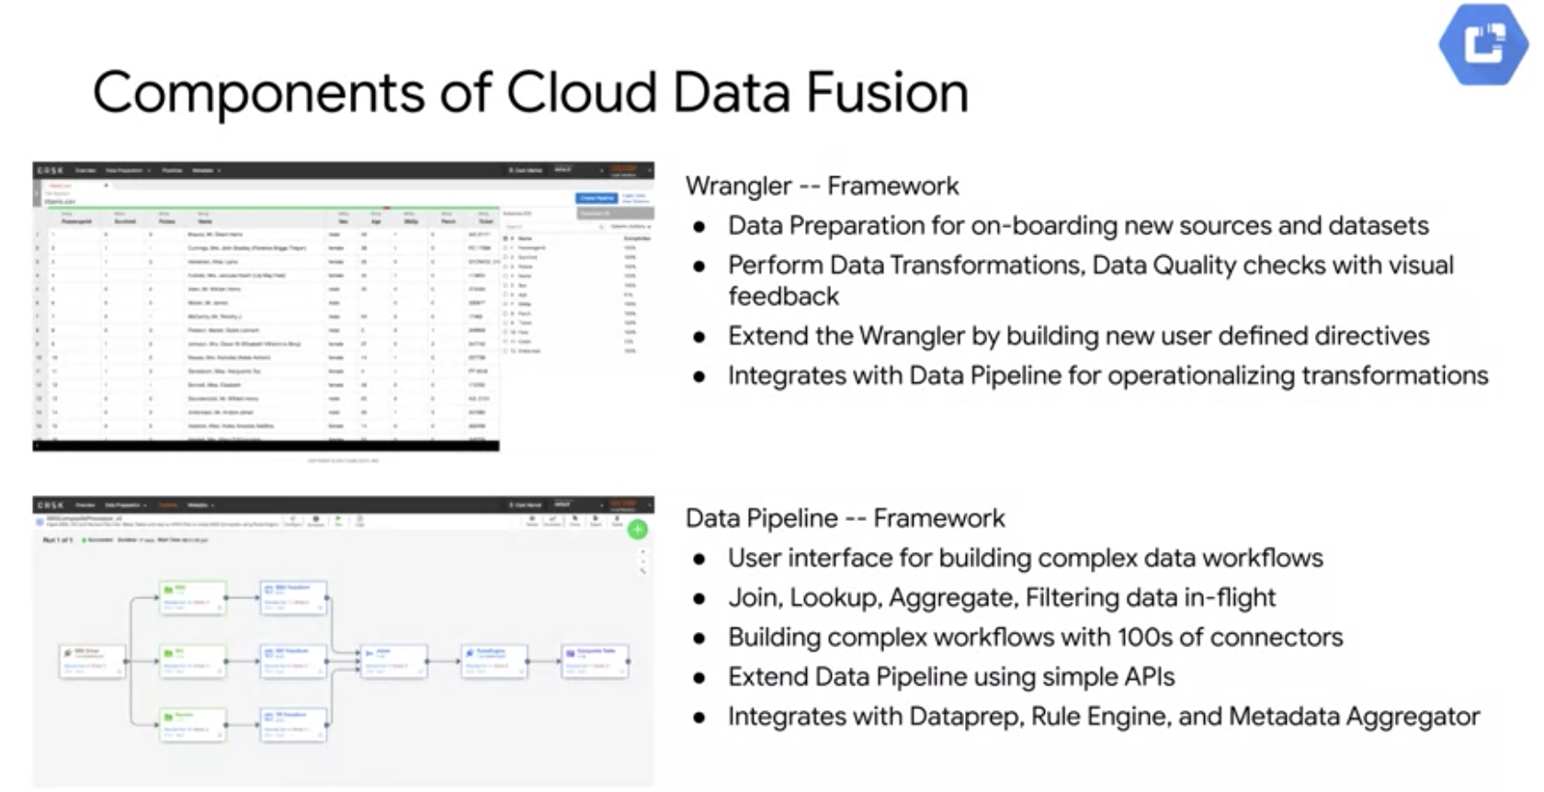

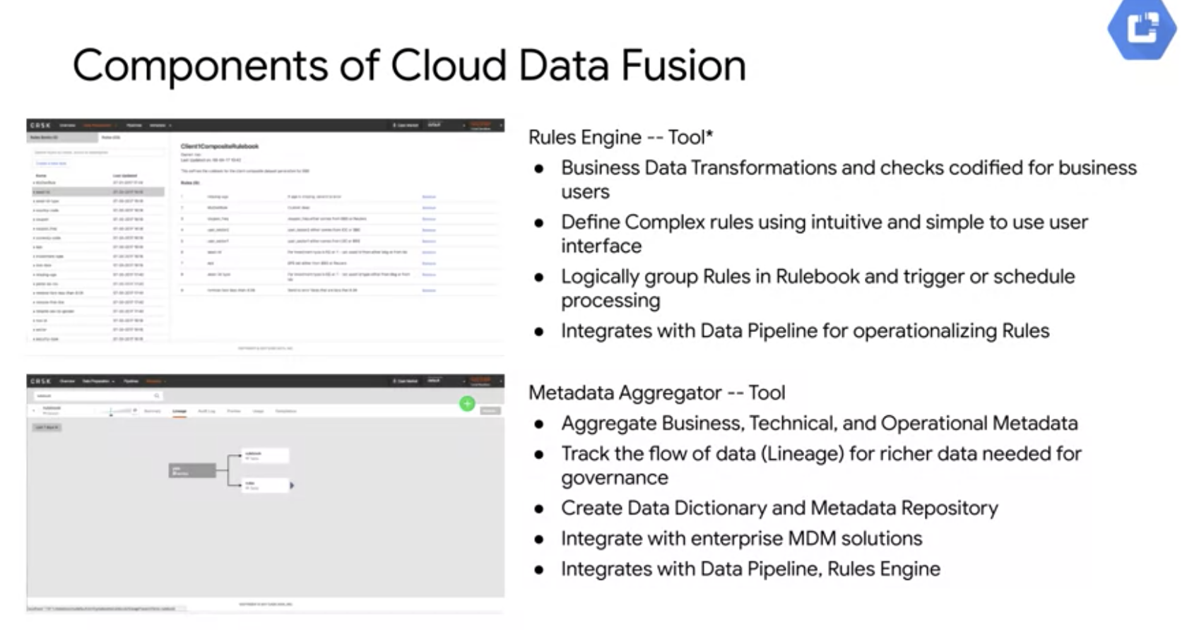

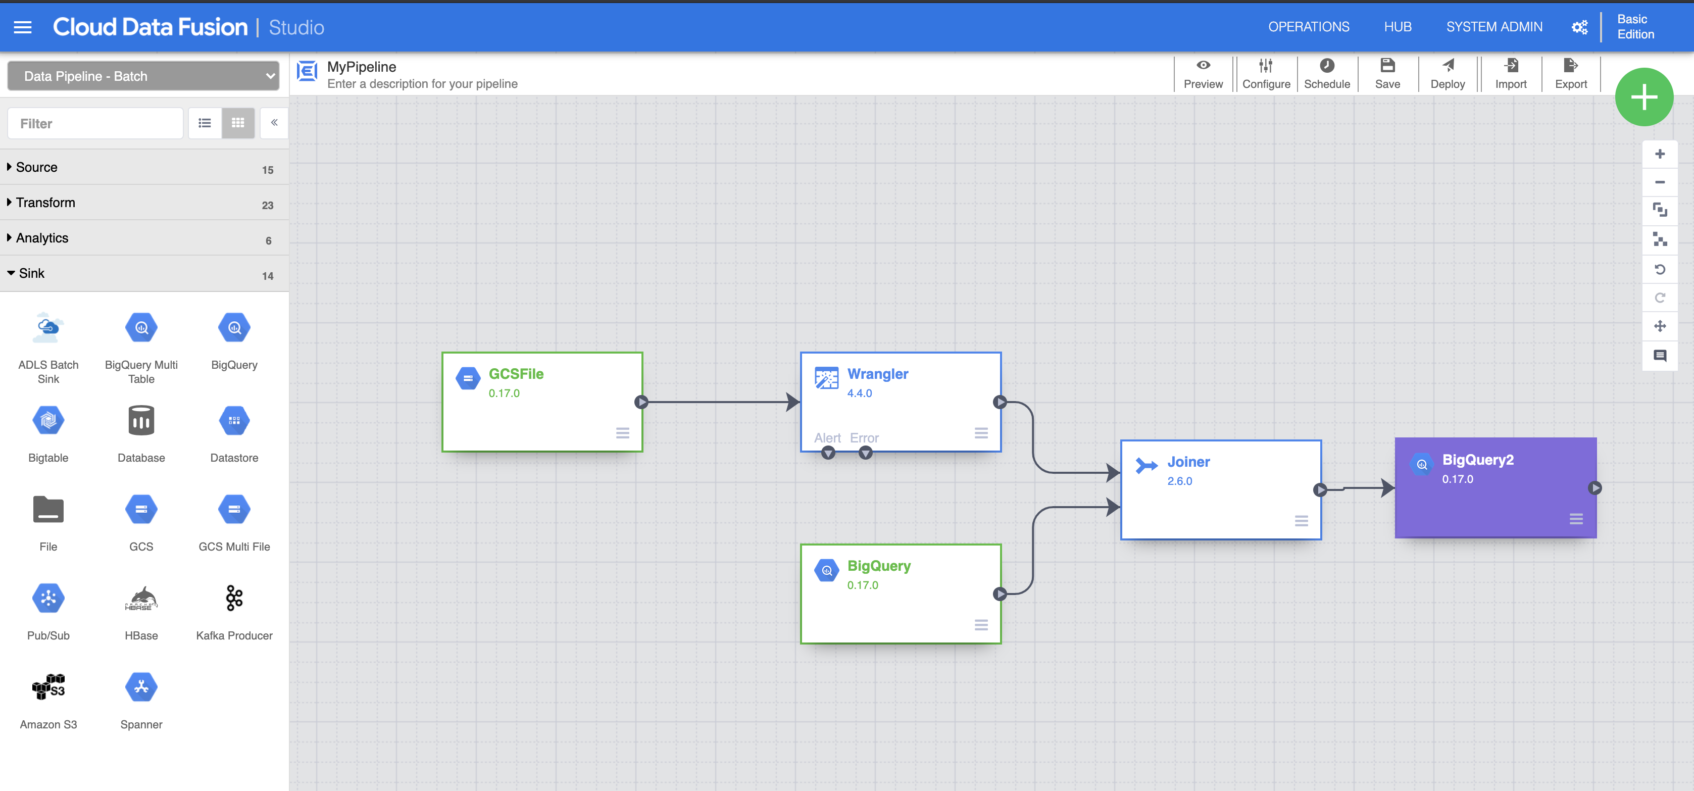

**Deploy and Run Pipeline –**

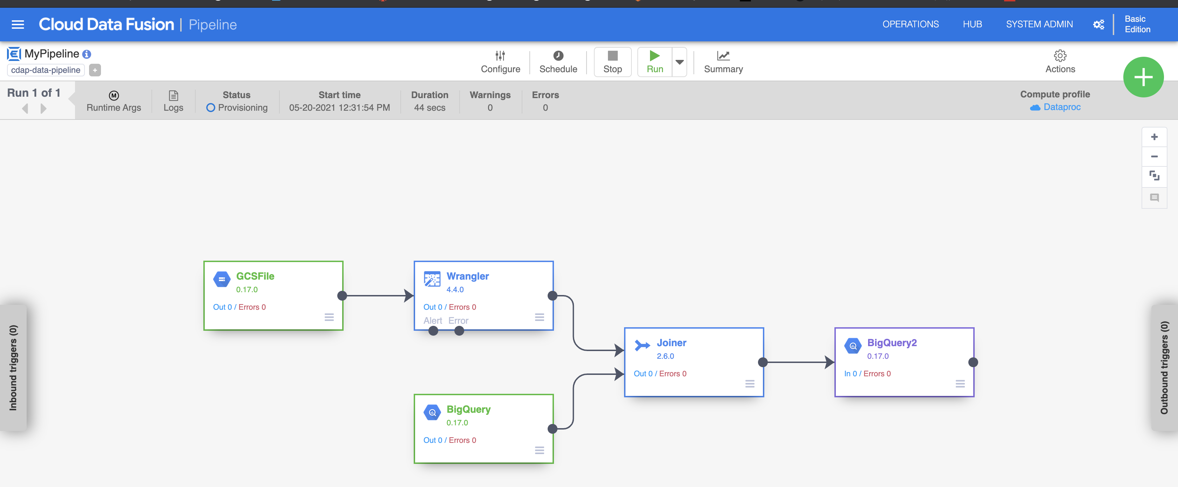

**Cloud Composer –**

<https://airflow.apache.org/docs/apache-airflow/stable/concepts/index.html>

## Defining the workflow

Now let's discuss the workflow you'll be using. Cloud Composer workflows are comprised of [DAGs (Directed Acyclic Graphs)](https://airflow.incubator.apache.org/concepts.html#dags). DAGs are defined in standard Python files that are placed in Airflow's DAG_FOLDER. Airflow will execute the code in each file to dynamically build the DAG objects. You can have as many DAGs as you want, each describing an arbitrary number of tasks. In general, each one should correspond to a single logical workflow.

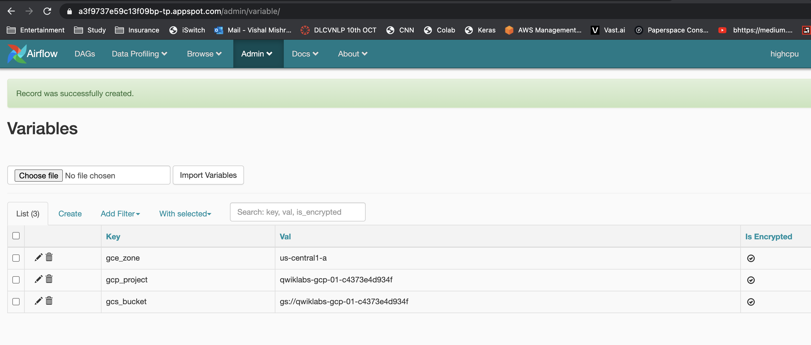

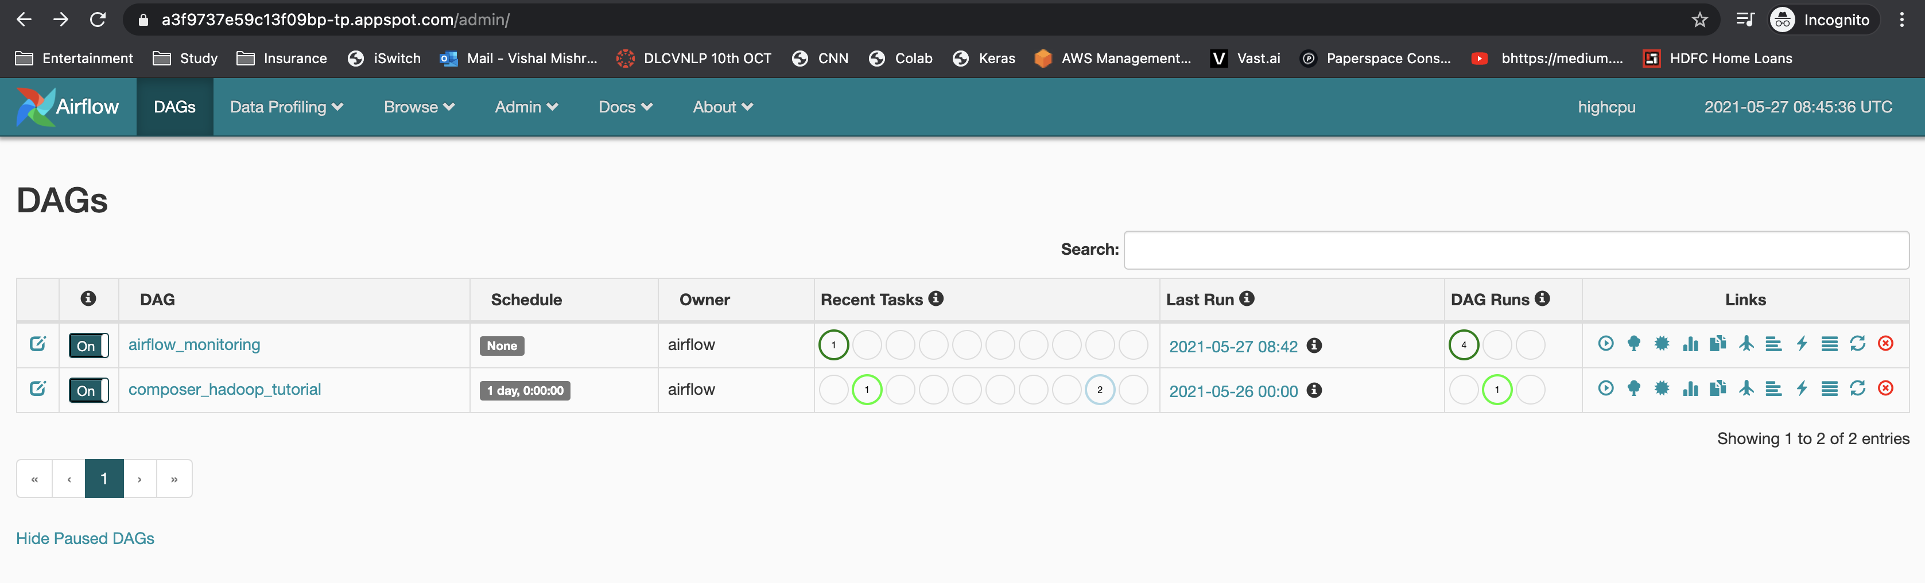

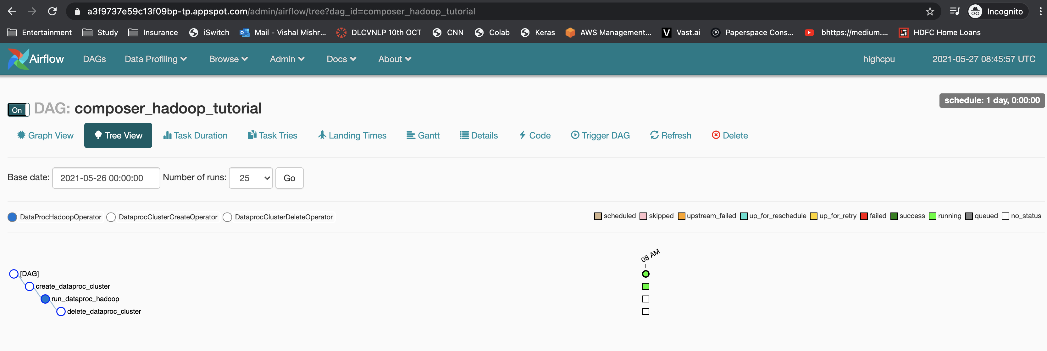

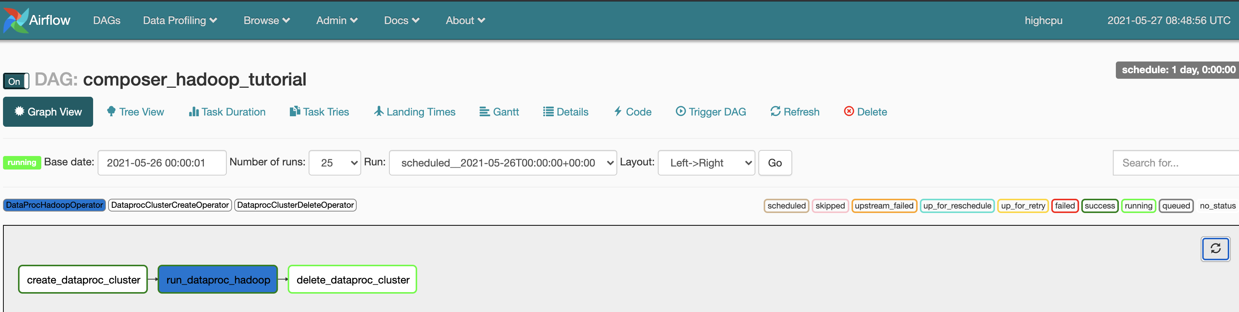

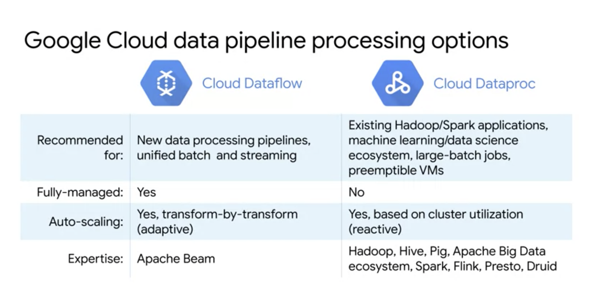

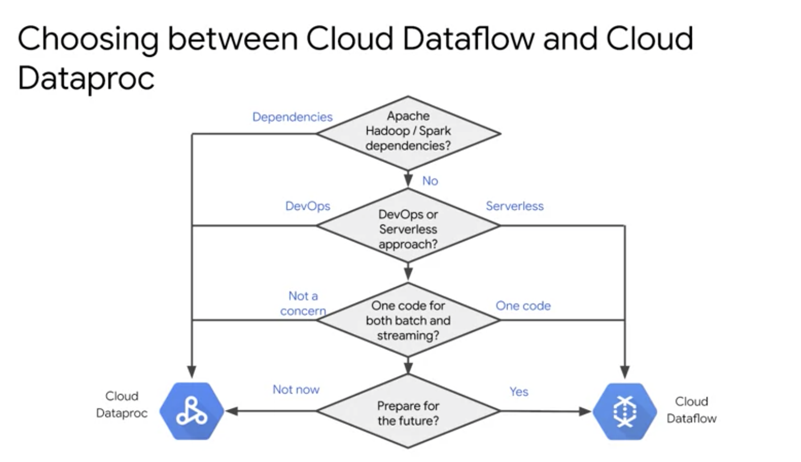

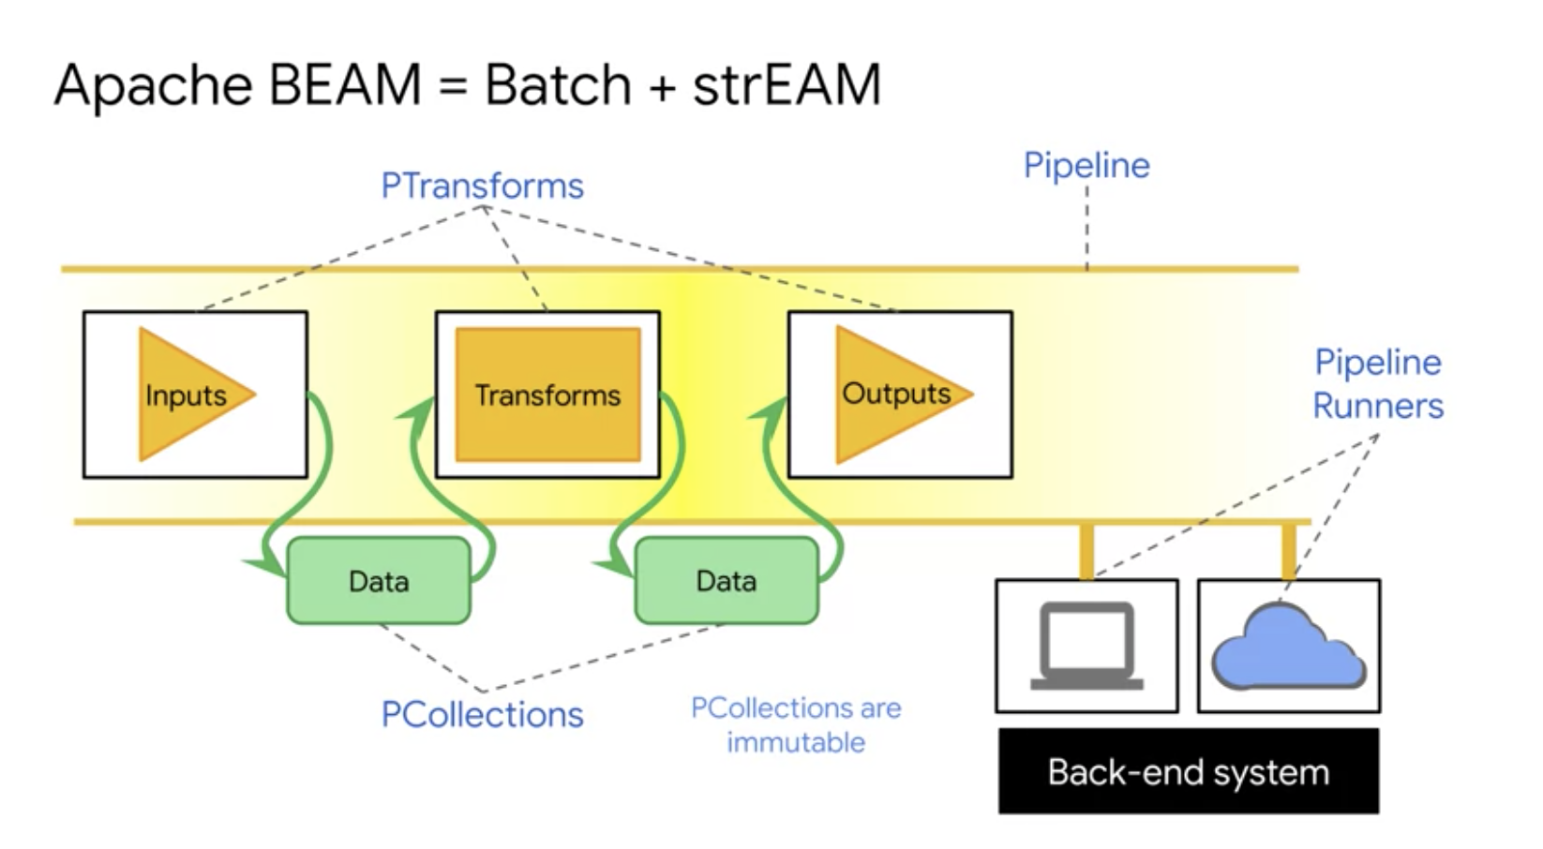

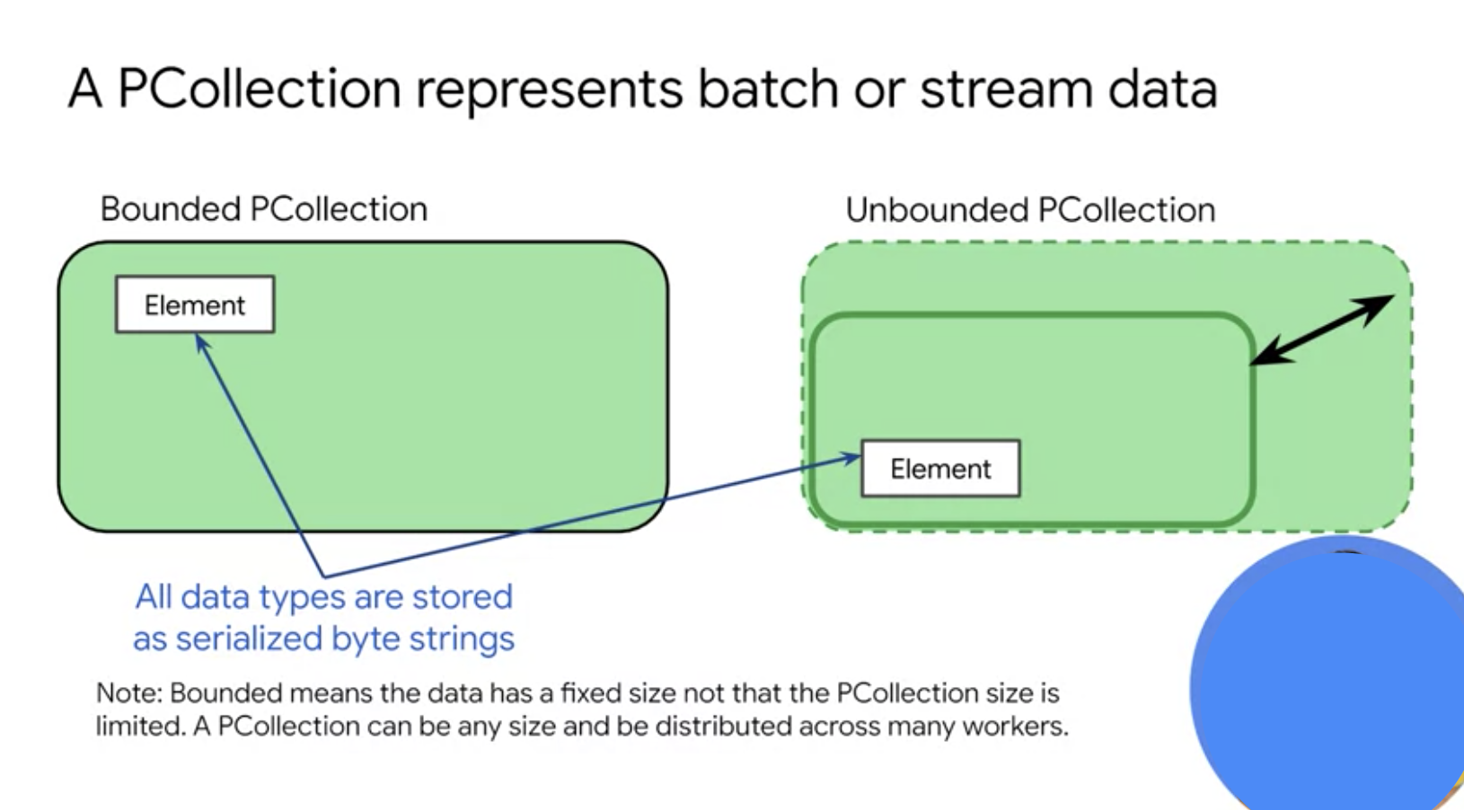

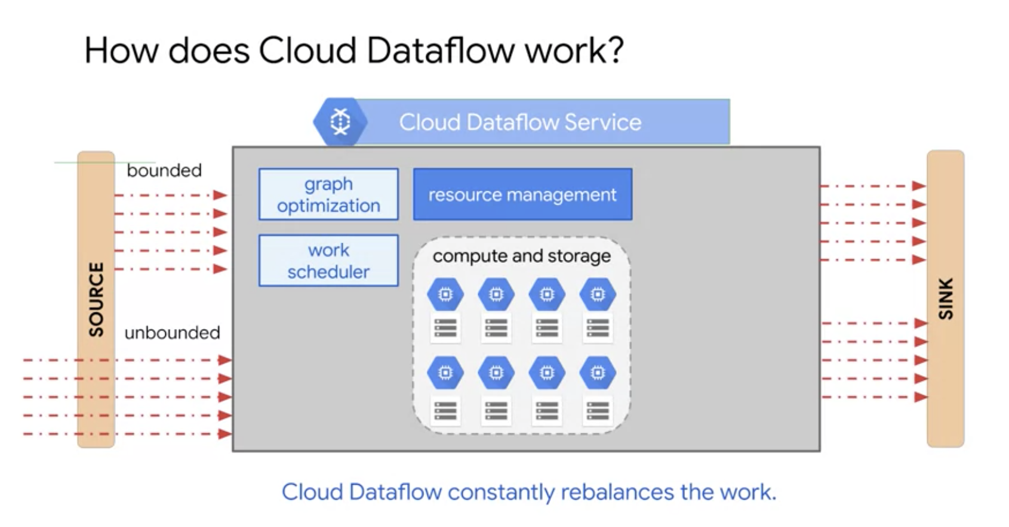

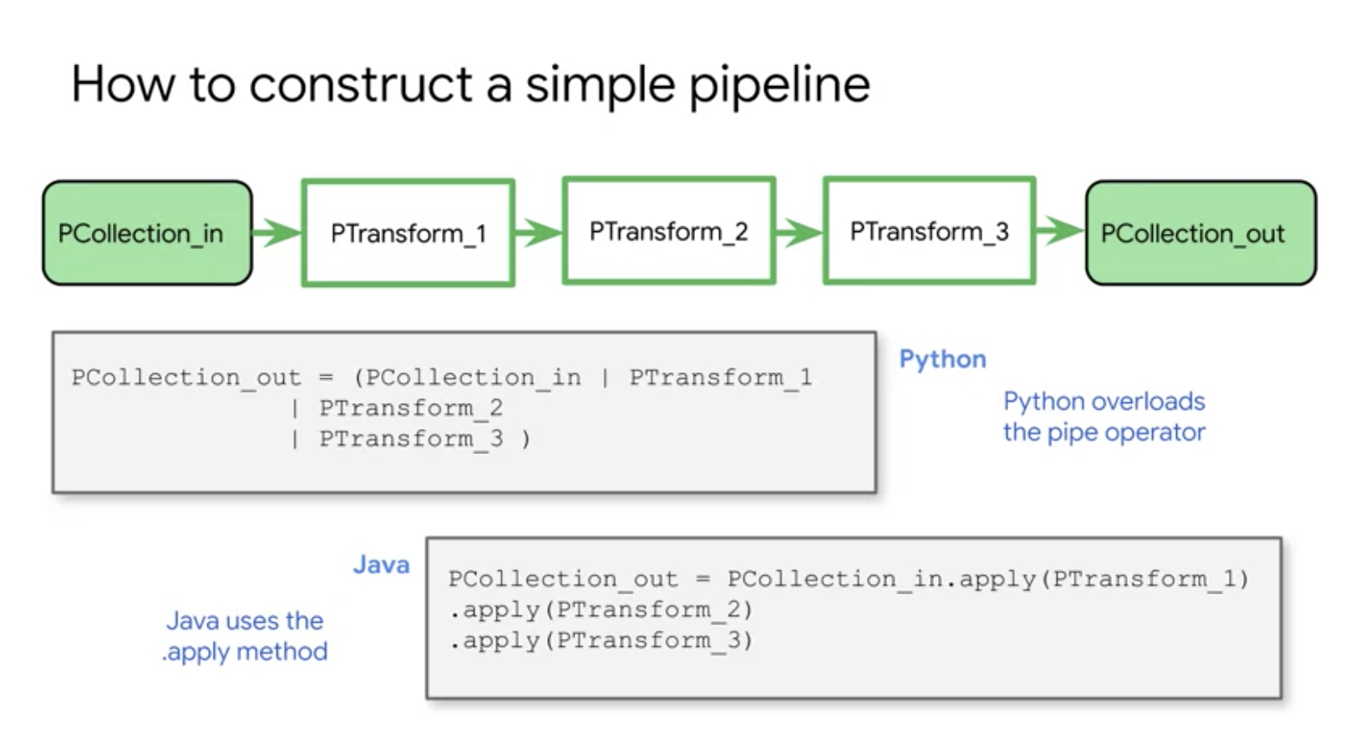

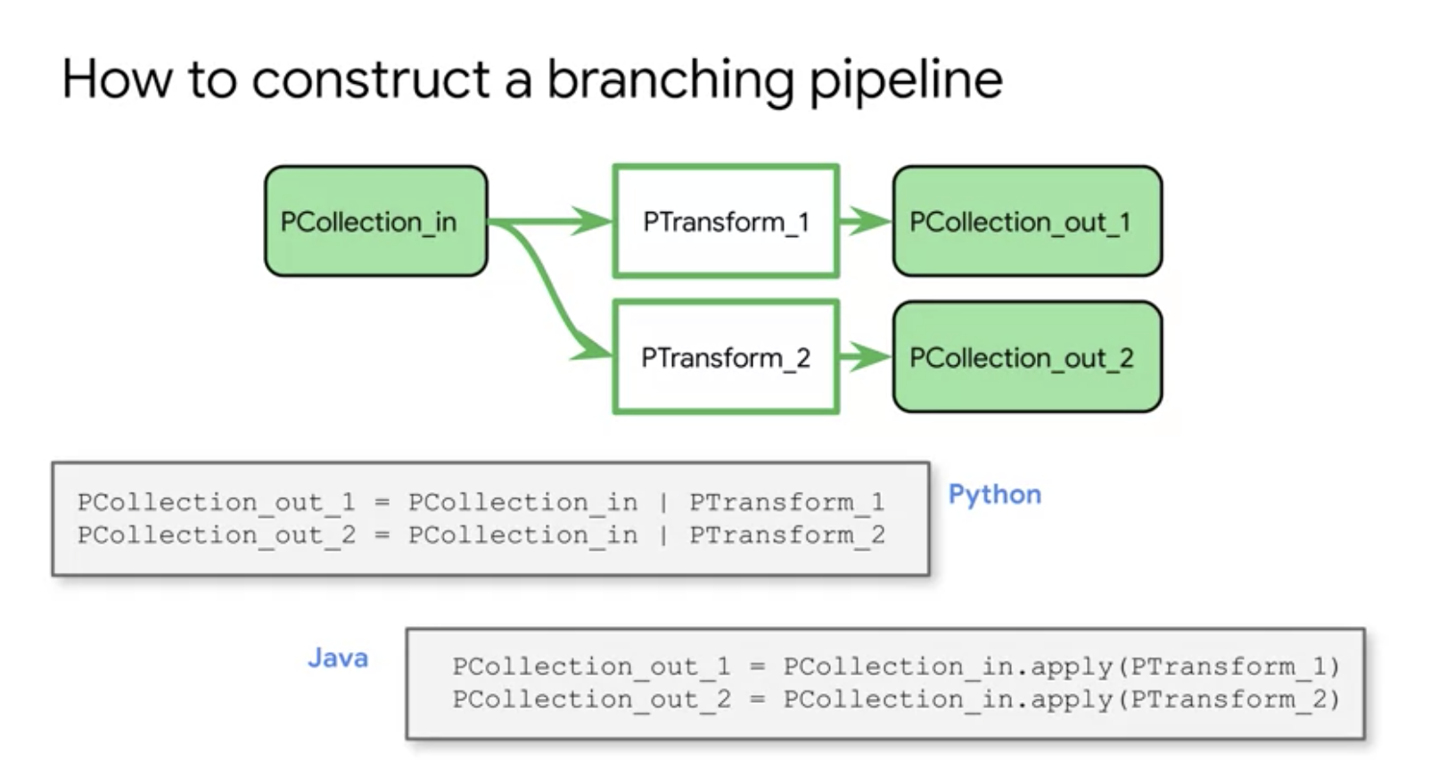

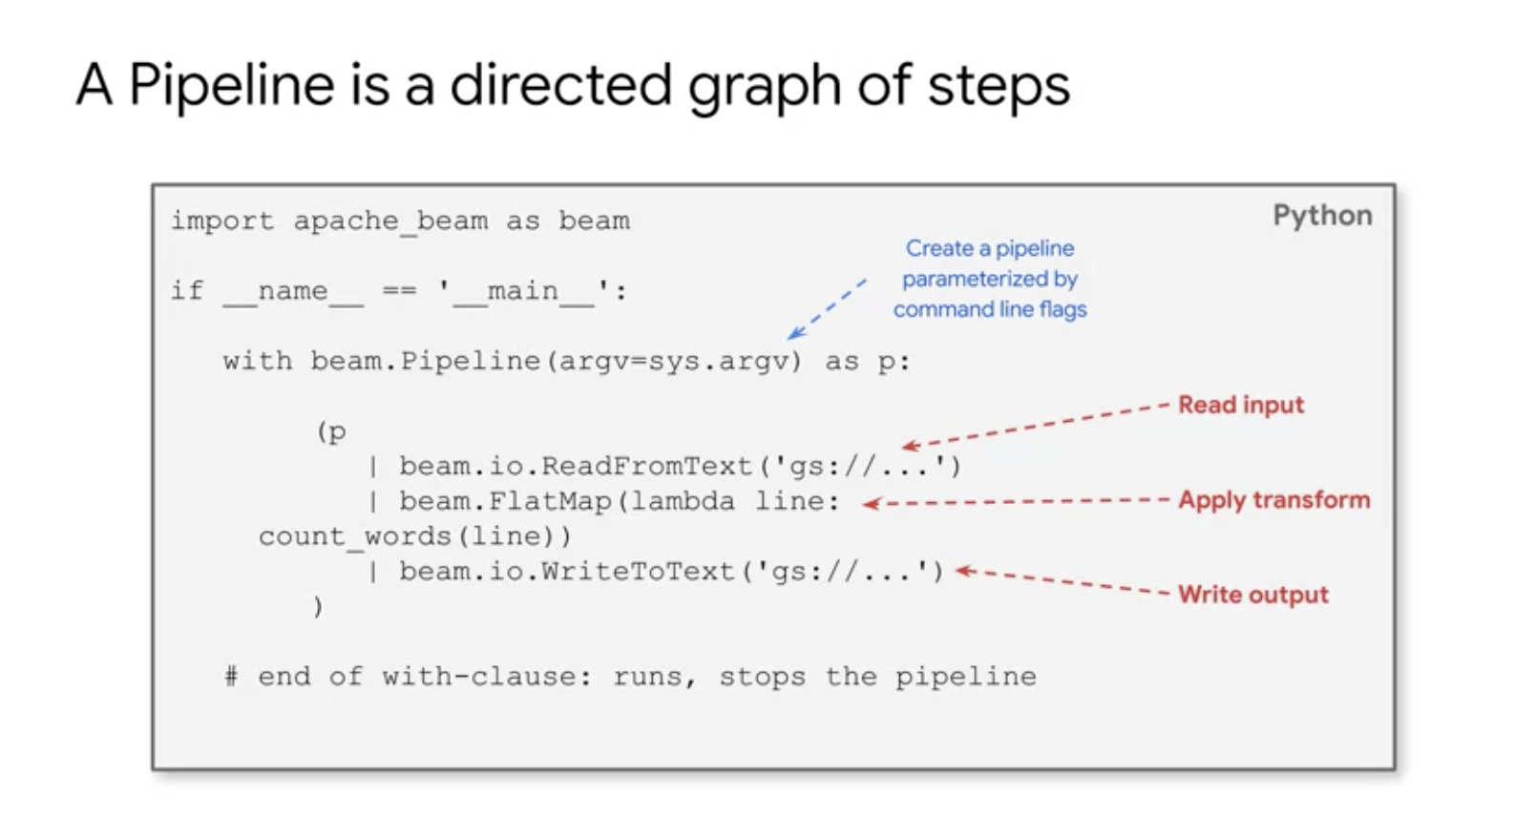

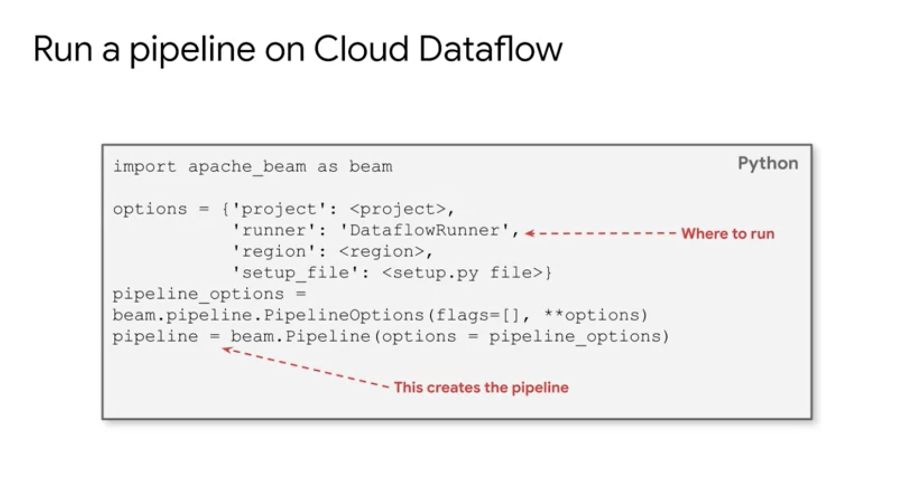

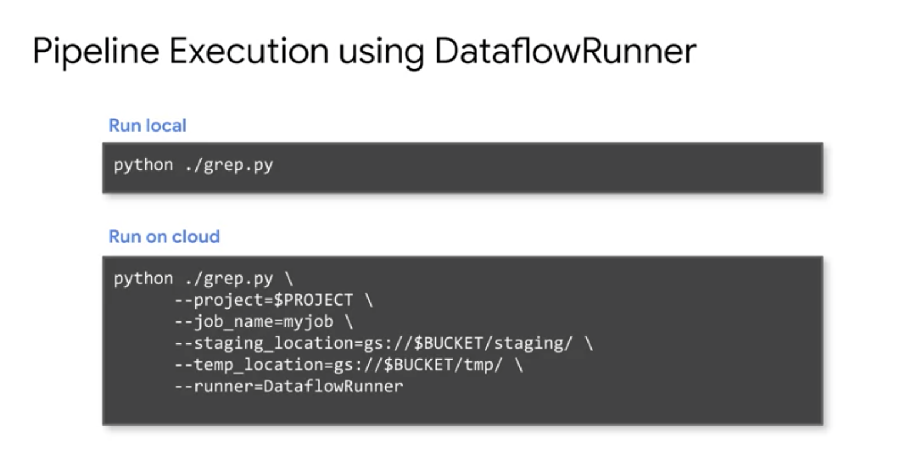

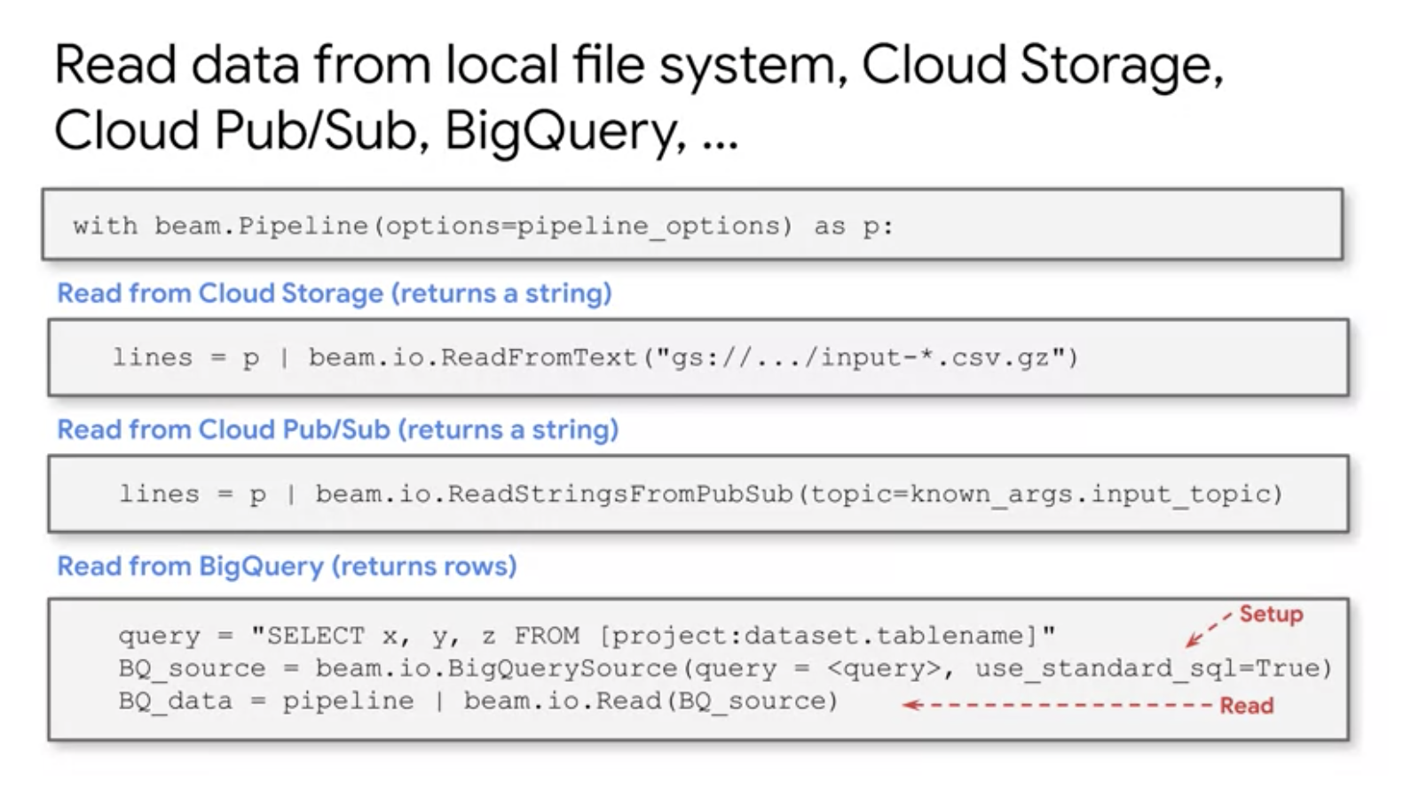

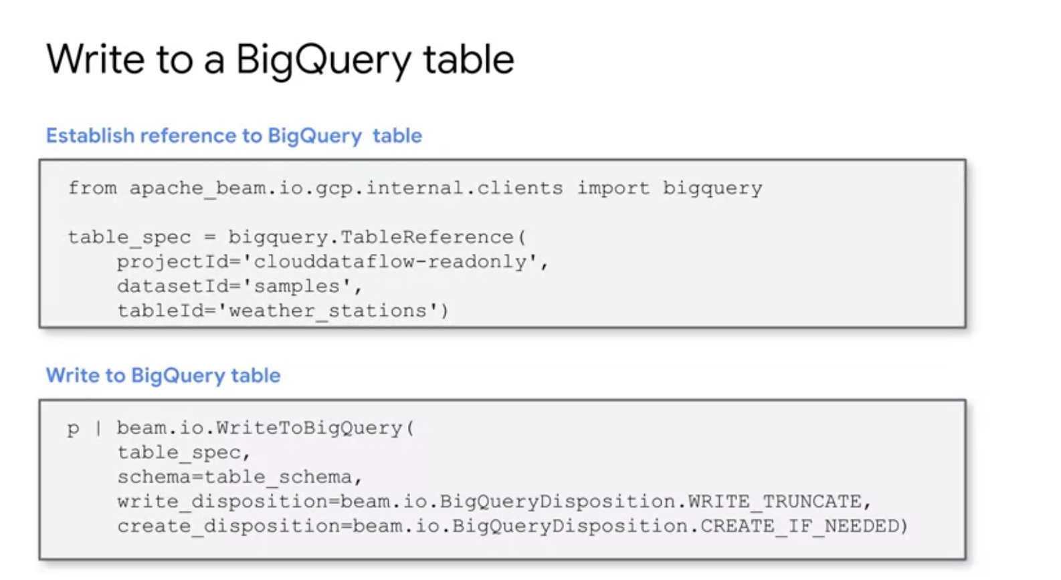

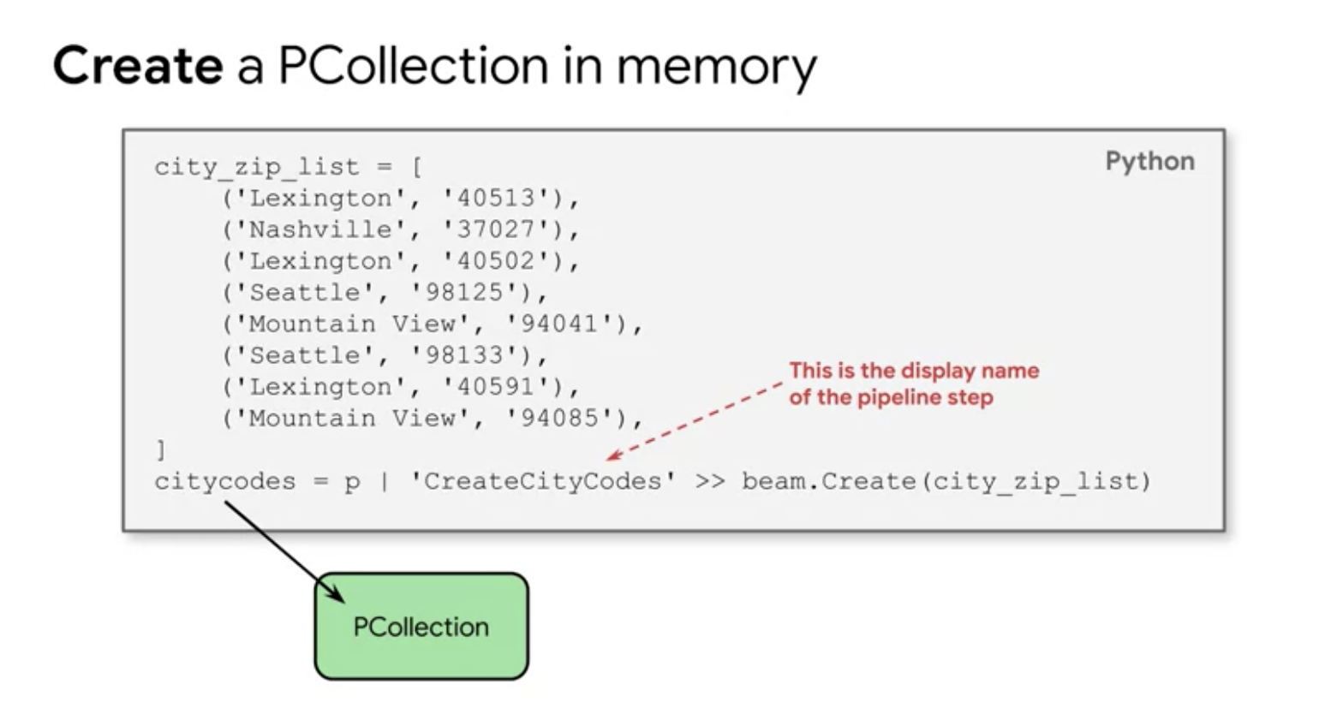

# **Transforming data with PTransforms**

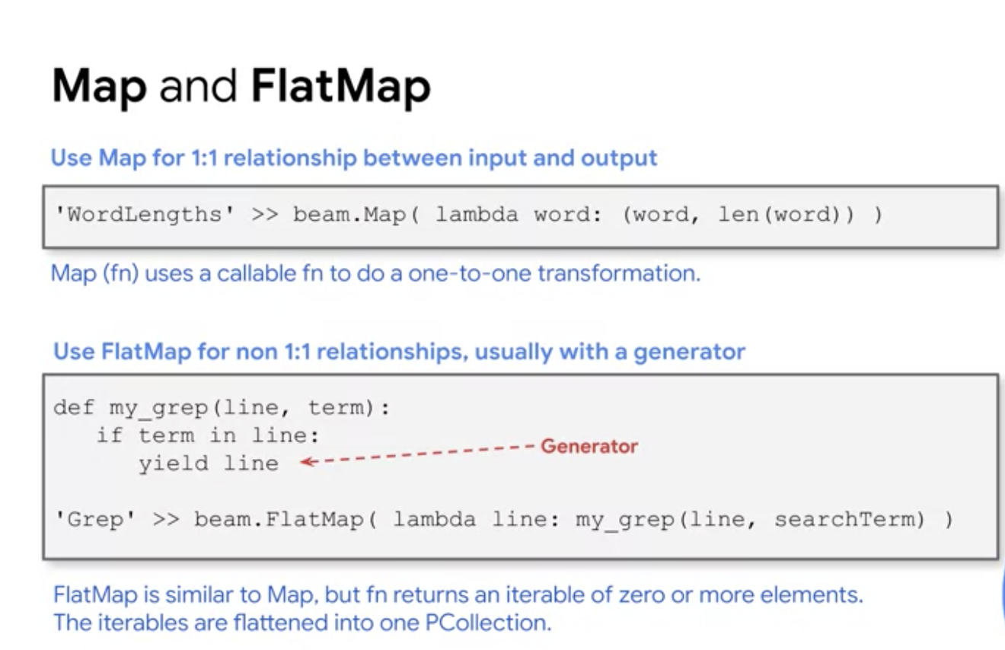

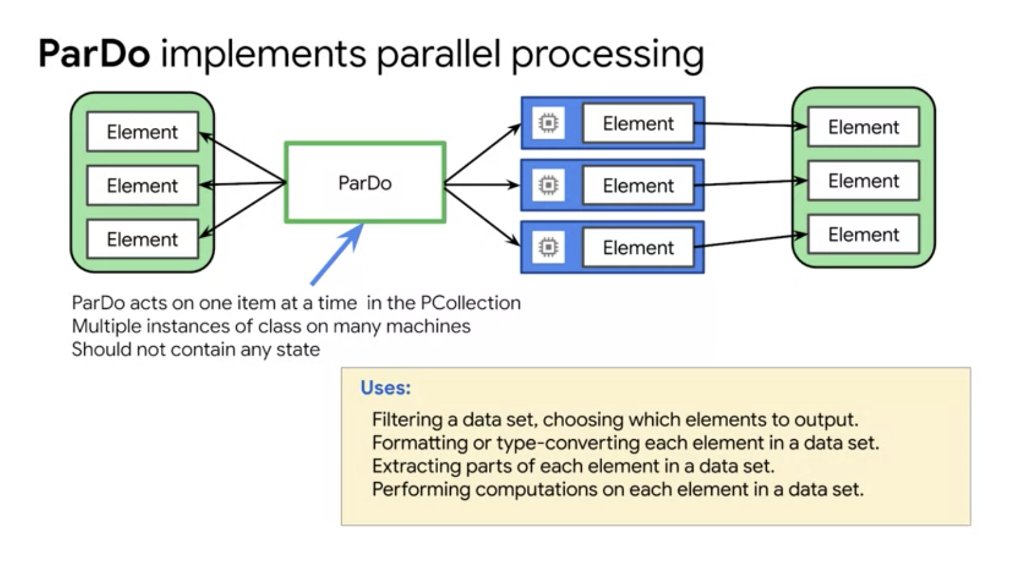

ParDo or parallel do is a common intermediate step in a pipeline.

You might use it to extract certain fields from a set of raw input records or

convert raw input into a different format.

You might also use ParDo to convert process data into an output format like table rows for big query or strings for printing. You can use ParDo to filter a dataset. So consider each elements in a PCollection, and either output that elements to a new collection or discard it or. Or you can use it for formatting or type converting each elements in a dataset. If your input PCollection contains elements that are of a different type or format that you want. You can use pardho to perform a conversion of each elements and output the results to a new PCollection.

You can use it for extracting parts of each element in a dataset as well. If you have a PCollection of records with multiple fields, for example, you can use a ParDo to parse out just the fields you want to consider into a new PCollection. And you can use ParDo for performing computations on each elements in a dataset. You can use ParDo to perform simple or complex computations on every elements or certain elements of a PCollection and output the results as a new PCollection. When you apply a ParDo transform, you need to provide user code in the form of a DoFn object. Where do function is a beam SDK class that defines a distributed processing function. Your do function code must be fully serializable, item potent and thread safe.

In this example, we're just counting the number of words in a line, and returning the length of the line. Transformations are always going to work on one element at a time here. Here we have an example from Python which can return multiple variables.

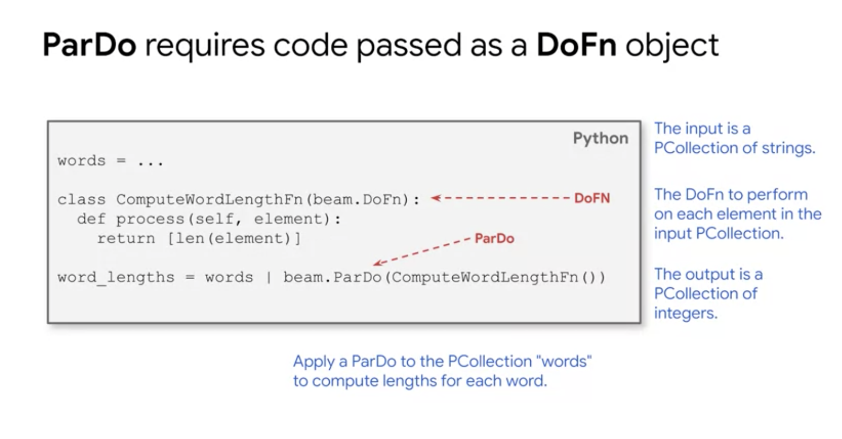

DataFlow Hands on =>

===================

git clone <https://github.com/GoogleCloudPlatform/training-data-analyst>

cd ~/training-data-analyst/courses/data_analysis/lab2/python

